Solution Partners ASP.NET Hierarchical Menu

Date | Version | Description | Author
April 2004 | 1.0 | Draft - General Information Relating to Menu | Jon Henning; Matt Edwards

Table of Contents
Solution Partners ASP.NET Hierarchical Menu 1
Table of Contents 1
Introduction 2
Technology 2
Overview 2
Menu Properties 2
Menu Item Properties 8
Performance and Menu Caching 9
Cross-Browser Implementation / UpLevel vs. DownLevel Rendering 10
CSS Support 11
DotNetNuke Integration 14
DotNetNuke Menu Module 14
SDK 16
Client Side API – spmenu.js 16
SmartNavigation 17
Concerning Windowed Controls 17
Additional Links 19
Contact Information 19

Introduction
Our mission is to build solid, long-term relationships with our customers through the provision of highly qualified consultants at a fair price while focusing on complete customer satisfaction. Part of the customer satisfaction is the transfer of knowledge on how to best utilize the projects technology. Our openness with our knowledge and our drive to share it should be self evident in the way we conduct ourselves. One example of this objective can be found on our website.
As you probably know by now Visual Studio .NET offers an awesome amount of features to assist you in the development process. With those features comes a whole new programming mindset. It is our goal to assist you with learning to program with that mindset.
ASP.NET provides an array of controls that you may use at no cost. One control Microsoft seemed to have forgotten was a menu control. Fortunately, just like in the Visual Basic world Microsoft provides a means for third party developers to offer you their custom controls. Since Solution Partners is not in the business of selling controls, but rather we want to help you in your development efforts, we decided to develop our own menu control and take you along for the ride by offering detailed articles and the full source code for each step in the process!

Technology

Overview

Menu Properties
Name | Description | Applies | Values
ArrowImage | Image used for arrows in menu items with submenus. You can specify a virtual path. If omitted, webdings font arrow will be used (but not all browsers support this font, therefore, the number 4 is shown instead). | Menu, SubMenu | String
BackColor | Background color for the control. Accepts standard HTML string or numeric color values. Applies to container, menu items and submenus, unless overridden by menu item and submenu properties. | Menu, SubMenu, MenuItem | String
BackgroundMenuImage | The background image to be displayed on the menu bar. You can specify a virtual path. Image is repeated horizontally. Accepted file types: gif, jpg, jpeg, bmp, png | Menu | String
Display | Orientation for menu control. | Menu | String: Horizontal, Vertical
Font-Bold | Standard font property. Applies to container, menu items and submenus, unless overridden by menu item and submenu properties. | Menu, SubMenu, MenuItem | Boolean
Font-Italic | Standard font property. Applies to container, menu items and submenus, unless overridden by menu item and submenu properties. | Menu, SubMenu, MenuItem | Boolean
Font-Names | Standard font property. Applies to container, menu items and submenus, unless overridden by menu item and submenu properties. | Menu, SubMenu, MenuItem | String
Font-Size | Standard font property. Applies to container, menu items and submenus, unless overridden by menu item and submenu properties. | Menu, SubMenu, MenuItem | String
ForceDownlevel | Whether to force the menu control to display itself as downlevel even if the browser is capable of uplevel. | Menu | Boolean
ForceFullMenuList | Renders the menu so that it is friendly to search engine crawlers. Setting this property to true will cause menu to always output all links within the menu. | Menu | Boolean
ForeColor | The foreground color (text color) for the control. Accepts standard HTML string or numeric color values. Applies to container, menu items and submenus, unless overridden by menu item and submenu properties. | Menu, SubMenu, MenuItem | String
HighlightColor | Highlight color. Accepts standard HTML string or numeric color values. Has no effect. | Menu, MenuItem | String
IconBackgroundColor | Background color for the submenu icons. Accepts standard HTML string or numeric color values. | SubMenu | String
IconImagesPath | Location of the icon images (in DNN this would be the Portal location). If not specified defaults to SystemImagePath. | Menu | String
IconWidth | Width in pixels of the icons in the submenus. | SubMenu | Integer
MenuAlignment | How the menu items are aligned in the menu bar. Has no effect if Display = “Vertical” | Menu | String: Left, Right, Center, Justify
MenuBarHeight | The height of the menu bar in pixels. | Menu | Integer
MenuBarLeftHTML | HTML encoded text that appears on the left side of the menu bar. | Menu | String
MenuBarRightHTML | HTML encoded text that appears on the right side of the menu bar. | Menu | String
MenuCSS-MenuArrow | Cascading style sheets name-value pairs that define the appearance of the arrow. | MenuItem | String
MenuCSS-MenuBar | Cascading style sheets name-value pairs that define the appearance of the menu bar. | Menu | String
MenuCSS-MenuBreak | Cascading style sheets name-value pairs that define the appearance of the submenu line breaks. | SubMenu | String
MenuCSS-MenuContainer | Cascading style sheets name-value pairs that define the appearance of the menu container. | Menu | String
MenuCSS-MenuIcon | Cascading style sheets name-value pairs that define the appearance of the submenu icons. | SubMenu | String
MenuCSS-MenuItem | Cascading style sheets name-value pairs that define the appearance of the menu items. | MenuItem | String
MenuCSS-MenuItemSel | Cascading style sheets name-value pairs that define the appearance of the selected menu item. | MenuItem | String
MenuCSS-MenuScroll | Cascading style sheets name-value pairs that define the appearance of the scrolling item when the menu doesn’t fit on the screen. | SubMenu | String
MenuCSS-RootMenuArrow | Cascading style sheets name-value pairs that define the appearance of the root menu arrows. | MenuItem | String
MenuCSS-SubMenu | Cascading style sheets name-value pairs that define the appearance of the sub menu. | MenuItem | String
MenuCSSPlaceHolderControl | Allows a placeholder tag to be specified so menu's css properties can be set within the <HEAD> tag. This allows the menu's  CSS style to be inserted at the desired location within the <HEAD> tag. It is highly  recommended that you place the following tag within the <HEAD> section.  <style id="SPMenuStyle" runat="server"></style>  Failure to do so will result in the menu placing its style at the very beginning of the output stream,  which I believe is not valid in some browsers. | Menu | String
MenuData | XML from which you wish the menu to create its hierarchy | Menu | String
MenuDataXMLFileName | The XML file from which you wish the menu to create its hierarchy. You can specify a virtual path. | Menu | String
MenuEffects-MenuTransition | Graphical method for display of a menu or submenu. | SubMenu | String:  None,  AlphaFade,  AlphaFadeBottomRight,  Barn,  Blinds,  Checkerboard,  ConstantWave,  Fade,  GradientWipe,  Inset,  Iris,  RadialWipe,  Random,  RandomBars,  Slide,  Spiral,  Stretch,  Strips,  Wheel,  Wave,  Zigzag
MenuEffects-MenuTransitionLength | Length of time in seconds the transition takes to run | SubMenu | Numeric
MenuEffects-MenuTransitionStyle | Allows you to tweak the pre-defined styles defined by the MenuTransition | SubMenu | String
MenuEffects-MouseOutHideDelay | Number of milliseconds that menu remains visible after mouse focus leaves the menu control. | SubMenu | Integer
MenuEffects-MouseOverDisplay | Visual effect to display when mouse focus moves over a menu item when MenuEffects-MouseOverExpand = “True”. Also occurs during mouse click when MouseOverExpand is false. Does not apply to submenus. | Menu | String: Highlight, Outset
MenuEffects-MouseOverExpand | Whether a menu item expands when mouse focus is over the menu item. | Menu | Boolean
MenuEffects-ShadowColor | If menu is showing shadow this is the color it will be. Accepts standard HTML string or numeric color values | SubMenu | String
MenuEffects-ShadowDirection | Determines the position the menu’s shadow will show | SubMenu | String:  None,  Top,  Upper Right,  Right,  Lower Right,  Bottom,  Lower Left,  Left,  Upper Left
MenuEffects-ShadowStrength | Determines how many pixels the shadow extends | SubMenu
MenuItemHeight | The height of submenu items in pixels. | MenuItem | Integer
Moveable | Whether the menu items are moveable on the menu bar via a slider handle. (disabled for now due to cross-browser issues) | Menu | Boolean
RootArrow | Whether to display an arrow beside a menu item when it has a submenu. | Menu | Boolean
RootArrowImage | Allows an image to be used for the root arrow instead of the webdings font. Only applies when RootArrow is true. | Menu | Boolean
SelectedBorderColor | The selection border color when an item is selected or highlighted. Accepts standard HTML string or numeric color values. | MenuItem | String
SelectedColor | The selection color (background color) when an item is selected or highlighted. Accepts standard HTML string or numeric color values. | MenuItem | String
SelectedForeColor | The foreground color (text color) when an item is selected or highlighted. Accepts standard HTML string or numeric color values. | MenuItem | String
SeparateCSS | Suppresses the sending of CSS Style being sent down to client, when this is true the minimum required css to get the menu working needs to be set within your page. This property was added mainly for pages with many menus on them that share the same css properties. | Menu | Boolean
ShadowColor | Color of the control’s shadow. Also applies to submenus. Accepts standard HTML string or numeric color values. | Menu, SubMenu | String
SystemImagesPath | Virtual path to submenu images. | Menu | String
SystemScriptPath | Path under which the spmenu.js file is located. | Menu | String

Menu Item Properties
Name | Description | Applies | Values
Children | Allows access to the nodes collection of children. | MenuItem | SPMenuItems
ID | ID of menu item. Must be unique within menu. | MenuItem | String
Image | Icon to display for menu item | MenuItem | String
ImagePath | If icon is not coming from the IconImagesPath then specify a path here. This is for admin icons. | MenuItem | String
ImageStyle | Allows for custom style attributes to be applied to the menu item’s image | MenuItem | String
ItemStyle | Allows for custom style attributes to be applied to the menu item | MenuItem | String
LeftHTML | Allows for a custom HTML to be displayed to the left of the menuitem’s Title. | MenuItem | String
Node | Allows access to the underlying XML node representing this menu item | MenuItem | XMLNode
ParentID | ID of parent menu item | MenuItem | String
RightHTML | Allows for a custom HTML to be displayed to the right of the menuitem’s Title. Note: In DNN this is for the selected menu item image. | MenuItem | String
RunAtServer | Causes a postback to occur when menu item is clicked. The MenuClick event will be fired passing in the clicked Menu Item’s ID. | MenuItem | Boolean
Title | Text displayed for menu item | MenuItem | String
ToolTip | Causes a tooltip to be displayed when mouse is over the menu item. | MenuItem | String
URL | Optional url to navigate to when menu item is clicked. Can also call a javascript function by putting javascript:myfunc() | MenuItem | String

Performance and Menu Caching
One of the goals in creating the menu was to make it stand alone by not having any other file dependencies. In order to do this the javascript for menu has been included within the assembly and will be sent down in the html stream with each page request. This is not an ideal situation for many sites since excess bytes are sent over the wire. In order to have the javascript cached it is highly recommended that you specify a SystemScriptPath and place the spmenu.js file in that specified location. Therefore the browser only has to download the javascript the first time it encounters the menu.

For browsers that support the loading of xml files through a URL (right now only IE 5+) the xml for the menu items are treated in much the same way as a .js file, thus after the menu xml is loaded the first time it is not necessary to transmit the file over the wire until it is modified again.
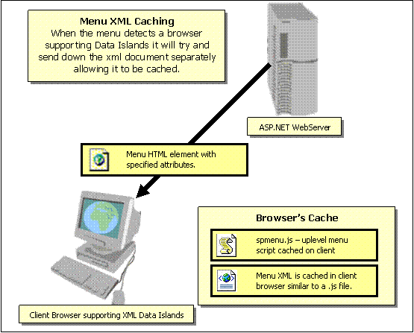

Cross-Browser Implementation / UpLevel vs. DownLevel Rendering
UpLevel rendering works as you would expect, the menus dynamically show and hide depending on the user's action. DownLevel rendering is very static, and is meant for older browsers that aren't up to par when it comes to DHTML or CSS. Here is an example of a DownLevel menu.
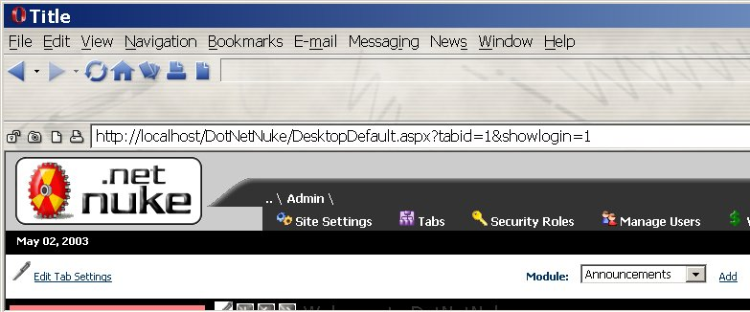
Opera 6 falls short of being able to render the menu in an uplevel fashion. However, with the improvements they made to v7, the menu can be rendered UpLevel.

Currently IE5+ (Win), Safari 1.x (Mac), Mozilla 1+ (All Platforms), Netscape 6+ (All Platforms), and Opera 7+ (All Platforms) are rendered UpLevel. All other browsers are rendered DownLevel.

There basically is two reasons the menu will render in DownLevel fashion.
1- inadaquate support for CSS
2- inadaquate support for DHTML, mainly being able to determine the
absolute position of the a HTML element relatively positioned on the
page.

CSS Support

While the menu allows you to specify style attributes like BackColor and font information in the property browser, it is recommended that you forego setting these properties in favor of using separate cascading style sheets. This will allow you to define all your settings concerning the look and feel of the menu within a central location.

In order to better understand how the menu chooses which style to apply you need to understand the css concept called selectivity. Every css compliant browser must follow these rules. I will explain this as simply as possible as it relates to the menu, however I do recommend you read the full specification found here if you have any additional questions. http://www.w3.org/TR/REC-CSS2/cascade.html#cascading-order

I like to think of CSS (cascading style sheets) as a waterfall that cascades down its various levels. For the menu’s sake lets say that we have defined a ForeColor property on our menu to be Blue and a font-size to be 18pt, but at the same time we have specified a MenuCSS-MenuItem called mymenuitem (in a separate css file) which also has a color (fore) defined as yellow.

The menu will render the following class for the container.

class=”solpartmenu1_spmitm mymenuitem”

The actual styles to be rendered on the client

.solpartmenu1_spmitm {color: Blue; font-size: 18pt; font-weight: normal; font-style: normal; border-left: Silver 0px solid; border-bottom: Silver 1px solid; border-top: Silver 1px solid; border-right: Silver 0px solid; cursor: pointer; cursor: hand; }

And

.mymenuitem { COLOR: yellow; }

While you may be tempted to think the order of the classes specified in the class attribute dictate which style wins, actually it is the order of the class definitions within the page. The last one defined wins.

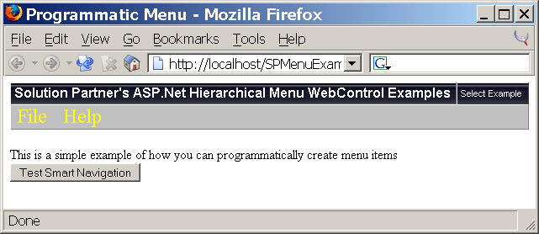

So if the mymenuitem class is defined after the solpartmenu1_spmitm then the fore color will be yellow and the font-size will be 18pt (since mymenuitem didn’t define this value). This is how I think of cascading… if the property was defined at a higher level then the lower level’s style doesn’t apply, however if it has not been defined yet then it will apply now and the lower levels values for that attribute will not be accepted.

If the solpartmenu1_spmitm was defined after the mymenuitem then no style from the mymenuitem will be applied, since both the font-size and the color were defined at a higher level.

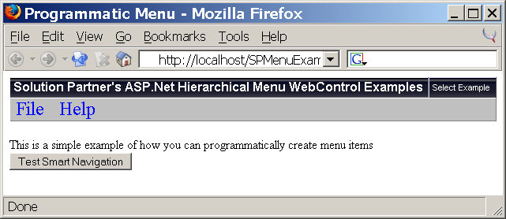

In addition to competing styles defined at the same level there is also the concept of styles inherited from a tag defined higher up the node hierarchy. So the class that is closest to the element we are rendering will override the parent setting regardless of its level. To give an example of this we will define a BackColor for the menu as Orange (note: this applies a style to the menu’s container). Additionally we will define a new class called mymenubar with a background-color of red.

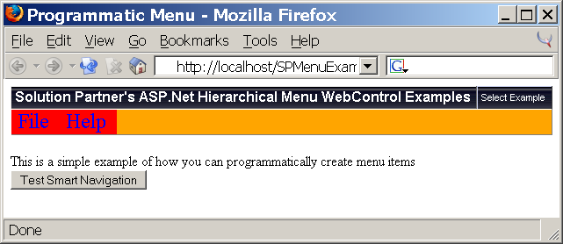

Regardless of the order in which the styles are placed within the page, the container will render Orange and the menu bar will render Red. This is because the MenuBar class is more specific to the menubar table than is the container.

<table id=”themenucontainer” class=”solpartmenu1_spmbctr”>
<tr>
<td>
<table id=”themenubar” class=”solpartmenu1_spmbar mymenubar”>

Here is a visual example of how the menu structure is made up. As you can see the menu container is outside of the menu bar, the menu bar contains one of more (root) menu items, which in turn contains three TDs, one for the icon (spmicn), one for the text (spmitm), and one for the arrow (spmarw). You should also note that the spmitm is applied on both the TR and the TD level.

File
Menu Container (spmctr)
Menu Bar (spmbar)
Menu Item Row (spmitm)
Menu Icon (spmicn)
Menu Item (spmitm)
Menu Arrow (spmarw)
New
Open…
Sub Menu (spmsub)
Menu Structure

Obviously there can be a lot more said regarding this topic, but my aim was to give you a little insight on how the menu works with CSS.

DotNetNuke Integration
Quite some time ago I was approached by Shaun Walker that he wanted to integrate my menu within his custom implementation of the IBuySpy Portal. Since my project was already open-source I didn’t see any reason not to, but never really expected it to go anywhere. Occasionally, they would ask me to enhance minor aspects of the menu to integrate with their portal better, which I gladly did. Then I started using DotNetNuke and realized the immense potential with the product and was driven to revamp the menu to help address some of the larger goals for the portal like CSS support, multiple menus, a menu module complete with a designer, and even a MenuDataProvider. I am happy to say that most of the menu enhancements have been successfully integrated into DNN and both products are better for it.

DotNetNuke Menu Module

One of the many requests of the DNN community was to make the menu more customizable. This led to the creation of the Menu Module Private Assembly. It includes a client side designer allowing the user to customize almost every aspect of the menu.

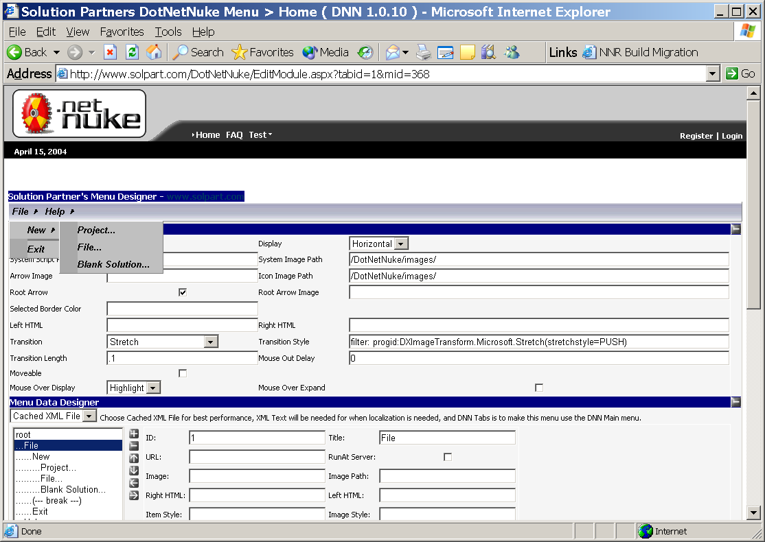

Additionally, I have introduced the concept of a MenuDataProvider.
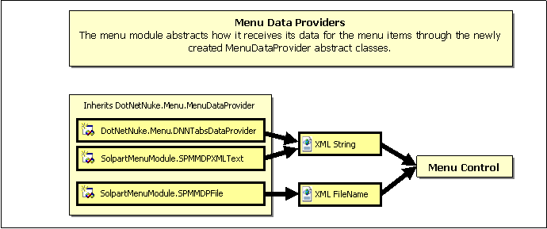
Each class must inherit the MenuDataProvider abstract class. When inheriting from this class you must override two methods. Though only one of these functions will contain code. If you expose a file that the browser can download then put your code in the GetXMLFileName and return the appropriate file name, otherwise you must return an XML string the menu can understand.

Public Overrides Function GetXMLFileName(ByVal TabID As Integer, ByVal ModuleID As Integer, ByVal XMLFileName As String) As String
Public Overrides Function GetXML(ByVal TabID As Integer, ByVal ModuleID As Integer, ByVal XMLFileName As String, ByVal ImagePath As String, ByVal Direction As String) As String

Since DotNetNuke doesn’t allow for you to customize the way the menu items are rendered (Arrows, etc.) this will allow you to plug in your provider by creating your own dll and adding the reference to the Menu Module’s SMM_DataProviders.xml file. I’d recommend starting by looking at the DNNTabsDataProvider for some guidance.

You may be asking, what is the difference between Cached XML File, XML File, and DNN Tabs in the Menu Data Designer combo?
- The Cached XML file uses static xml files and can be cached by some browers. Their content cannot be modified.
- The XML File was introduced by the eventual need to localize the menu. It allows a static xml file to be treated like a programmatically created menu, thus it will have its MenuItems collection available on the server for localization.
- The DNN Tabs loads is responsible for generating the xml for the DNN menu.

SDK
The SDK currently contains all the source code for the menu, along with a web project that contains several menu examples, and all of the DotNetNuke specific code.

Client Side API – spmenu.js
Early versions of the menu included separate js files for each browser it supported. This caused many problems with maintenance and when new browsers were introduced. So now there is a single js file responsible for rendering the menu correctly. Additionally the ability to have multiple menus on the same page was introduced. Since the menu has to handle each menu’s events separately, along with many different styles applied to each it has been developed using javascript objects. In the menu is created completely on the client side with a javascript call.

function spm_initMyMenu(oXML, oCtl) //Creates SolpartMenu object and calls generate method
{
m_oSolpartMenu[oCtl.id] = new SolpartMenu(oCtl);
m_oSolpartMenu[oCtl.id].GenerateMenuHTML(oXML);
}

Every menu on you page is instantiated and placed in the m_oSolpartMenu array (indexed by the menu’s ID). The oCtl passed to it is the SPAN tag containing all of its attributes (i.e. BackColor). Once the menu is instantiated and initialized the GenerateMenuHTML method is invoked, passing in the XML relating to the menu (for IE this is the actual XMLDOM object, for Netscape/Mozilla this uses the createDocument, for all other browsers it uses a complex javascript array to mimic xml nodes).

A quick look at the constructor will show you some of the client-side properties the menu supports…

//--- Appearance Properties ---//
this.fontStyle=spm_getAttr(o, 'FontStyle', 'font-family: arial;');
this.backColor=spm_getAttr(o, 'BackColor');
this.foreColor=spm_getAttr(o, 'ForeColor');
this.iconBackColor=spm_getAttr(o, 'IconBackColor');
this.hlColor=spm_getAttr(o, 'HlColor', '');
this.shColor=spm_getAttr(o, 'ShColor', '');
this.selColor=spm_getAttr(o, 'SelColor');
this.selForeColor=spm_getAttr(o, 'SelForeColor');
this.selBorderColor=spm_getAttr(o, 'SelBorderColor');
this.menuAlignment = spm_getAttr(o, 'MenuAlignment', 'Left');
this.display=spm_getAttr(o, 'Display', 'horizontal');
this.MBLeftHTML=spm_getAttr(o, 'MBLHTML', '');
this.MBRightHTML=spm_getAttr(o, 'MBRHTML', '');

Eventually the menu will expose events and additional methods, but for now the only real method exposed is the GenerateMenuHTML. To see the power of being able to render the menu on the client I highly recommend playing with the MenuDesigner found in the SDK MenuExamples or on www.solpart.com/dotnetnuke.

SmartNavigation
SmartNavigation is an interesting technology by Microsoft, that in my opinion, encourages bad development practices. I say this because it currently only works with Internet Explorer. Since a most developers test their code against IE first they are encouraged by the instant responses they are receiving since postbacks aren’t visible (therefore they tend to overuse the postbacks for many events on the page). When they try their application out on another browser, they are generally surprised at how poor the performance is. With all that said you probably are wondering what this has to do with the menu. Well I have found that SmartNavigation does not raise the onreadystatechange event when the page is loaded. This event is required by the menu to render itself correctly. I have worked around this issue by implementing a setTimeout to continuously poll the window’s state and when it finally loads my initialization function be called. While this is somewhat of a kludge, I have found no other way to deal with it. The only affect the end user will see is that the menu is not rendered until about a second after the postback occurs.

Absolute Positioning
While you may think that the menu would render the easiest if everything was absolute positioned, this has proved to be difficult to make it work in the same manner in all browsers. Therefore, for the time being the menu only supports being positioned relatively within any html element.

Concerning Windowed Controls
Most browsers today implement something called windowed controls. These controls are special in that they do not “live” within the document. Instead they reside on top of the html document. Probably the most popular of these controls is the SELECT dropdownlist. This is one of the few windowed controls that actually has to be windowed.

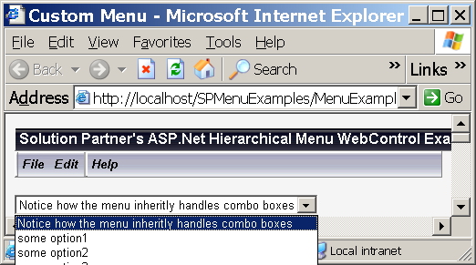
Looking at example 2 from the SDK you will see that the dropdown list there will show its contents completely outside IE, let alone the html document. For this reason the control has to “live” on top of all html elements. Thus it is not possible for the menu (or any non-windowed html element) to display on top of this control.

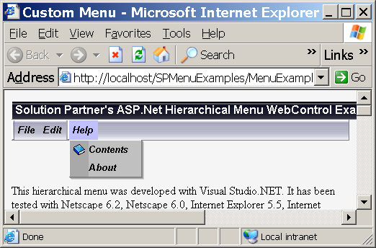
Therefore the menu has been coded to detect when there is an overlap with one of these controls and if it finds one it will hide it.

For more information on this see http://support.microsoft.com/default.aspx?scid=kb;en-us;177378

Additional Links
Solution Partners, Inc. – http://www.solpart.com
DotNetNuke – http://www.dotnetnuke.com
MS Official ASP.NET Site – http://www.asp.net
Solution Partner’s TechCorner – http://www.solpart.com/TechCorner

Contact Information
Jon Henning – jhenning@solpart.com

